COMP 472 Template for the Reports
Annes Cherid¹ and Second Author² and Third Author³
¹ 40038453 cherid.annes@gmail.com
² 40029076your@email1.com
³ ID-number3 your@email1.com

- 1/2 to 1 page: Introduction and technical details.
  - Implementation of the tree

In regard to our implementation of the tree, we have decided to represent the tree as an adjacency list. Meaning, in python's terms, it is a dictionary of lists. The first key of the dictionary is the node index, the value of the key is the list of nodes that are children to the key.

For example

[0: [1, 2, 3 ... ,9], 1: [10,11, 12, 13, ..., 18], ... 9: [91, 92, …, 99]…]
Which can be illustrated by this diagram:
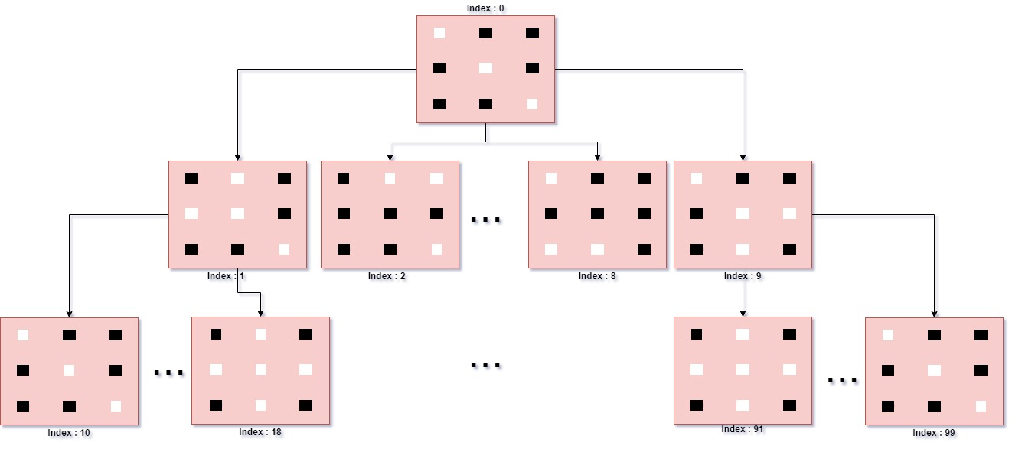

where the value of key 0 is [1, 2, 3 ... ,9], which are the children nodes of node 0.
With this approach, we can easily generate nodes while knowing who the parent is and therefore backtrack all the way up to the root node. Like this, as soon as we get an answer, we can backtrack to its root node and output a solution to the file.
NEED to talk more about technical details.: EXPLAIN Openlist&Closedlist

  - DFS approach

As a result of the tree implemented, when we use the DFS search, we first generate the complete state space puzzle tree (until max depth) then we run DFS on that tree. This will read all the contents of the list in every key.

  - BFS approach
The Best First search is also an algorithm that works with our tree thanks to our adjacency list system. As mentioned before, the tree is a dictionary of lists where we can now easily traverse every child. Since they are implemented in an orderly manner, we are using Best-First Search by going over all the tree from left to right. Adding to this, a heuristic method to calculate which node is more likely to have an optimal answer or which node has a better progress rate. This progress rate is calculated by the number of black dots left (basically count how many 1s there is left). With this, we can see which node is closer to goal and which node is not and then prioritize the lower heuristic value first since we could find a goal state faster.

  - A* approach
Our approach for A* Algorithm is pretty much the same as the BFS approach but with an additional heuristic cost the deeper the depth is in the tree.
  - Difficulties of BFS & A*
As we were approaching to our heuristic method of counting the number of black dots, we realized that it is not optimal in certain cases where there are
- 5 black dots left since they could be in an order such that they form a cross shape and one move can reach the goal state.
- 4 black dots left since they could be in an order such that they form a “T” shape and one move can reach the goal state.
- 3 black dots left since they could be in an order such that they form an “L” shape and one move can reach the goal state.

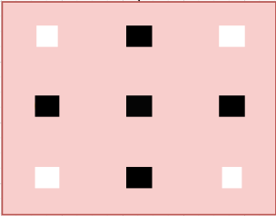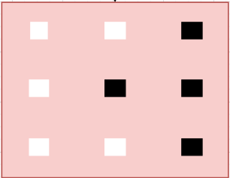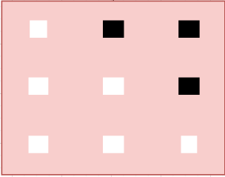

We were able to implement methods that can handle those kinds of cases which will give them a heuristic value of 1 and prioritize those cases as soon as they are spotted. The lower the value the higher priority it has.

  - Difficulties of DFS

We made our program as generating the whole tree first and then do the DFS. Due to that implementation, generating the tree is a time-consuming process and Input test #1 and #4 are heavy to compute. Therefore, in our solution, we have only the solutions of input test #0, #2, #3 and #5 which were shorter in time when computing. We were not aware that we should not generate the whole tree. We thought that generating the tree, then running DFS on that tree would be a good approach.
We have taken realization of the problem and we immediately thought of how to tackle this issue while keeping our main algorithm and not start from scratch

A Sample Heading (3rd level). Blah blah blah

A Paragraph Heading (4th level). Blah blah blah

- 1 to 1 1 2 page: A description and justification of your heuristic(s). In particular, describe how it works, its strengths and its weaknesses (yes, indicating its weaknesses will give you more points as it shows that you are aware of them!)
- 1/2 to 1 pages: A description of any difficulties that you have encountered and how you addressed them.
- 2 pages: An analysis of the results of your experiments. In particular, you must compare and contrast the results of the search algorithms and the heuristic(s). Please note that your report must be analytical. This means that in addition to stating the facts (e.g. how many moves does a search algorithm yield), you should also analyse them (i.e. explain why something behaves this or that way, in which case something would be better than another . . . ).
- 1 2 page: In the case of team work, a description of the responsibilities and contributions of each team member.

- Tables, figures and other goodies

Table 1 gives a summary of all heading levels.
Table 1. Table captions are used to indicate the content of the table.
Heading level | Example | Font size and style
Title (centered) | COMP 472 Template for the Reports | 14 point, bold
1st-level heading | First section | 12 point, bold
2nd-level heading | A subsection | 10 point, bold
3rd-level heading | A sub subsection | 10 point, bold
4th-level heading | Lowest Level Heading | 10 point, italic

  - Equations

Equations are centered and set on a separate line, as in Equation (1).

x + y = z (1)

Fig. 1. This is the caption of the figure. Example: Values of Data A and Data B over time.
  - Figures
A Reference to Fig.1.

  - List of References
The following bibliography provides a sample reference list with entries for journal articles [1], an LNCS chapter [2], a book [3], proceedings without editors [4], as well as a URL [5].

References
- Author, F.: Article title. Journal 2(5), 99–110 (2016).
- Author, F., Author, S.: Title of a proceedings paper. In: Editor, F., Editor, S. (eds.) CONFERENCE 2016, LNCS, vol. 9999, pp. 1–13. Springer, Heidelberg (2016).
- Author, F., Author, S., Author, T.: Book title. 2nd edn. Publisher, Location (1999).
- Author, F.: Contribution title. In: 9th International Proceedings on Proceedings, pp. 1–2. Publisher, Location (2010).
- LNCS Homepage, http://www.springer.com/lncs, last accessed 2016/11/21.

